In this experiment, I have finished it using Fabric Testbed
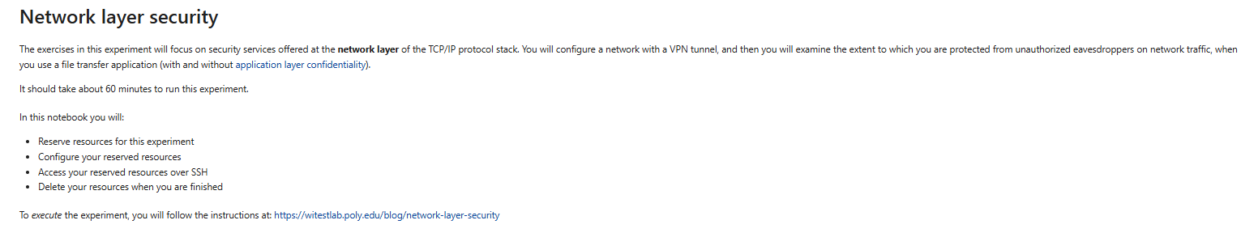
So, first we start by creating a slice..

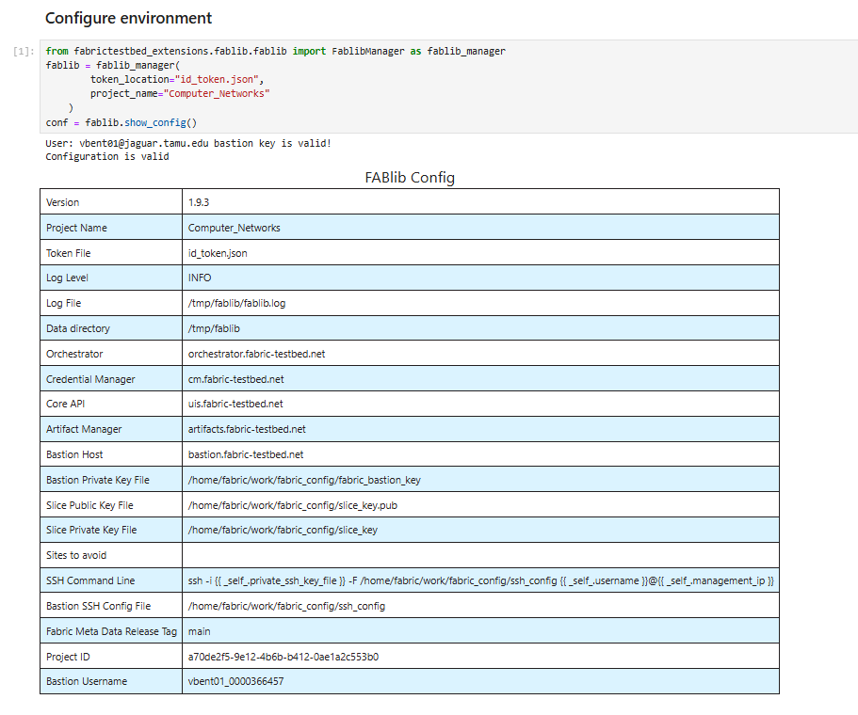
Then we define configs for this experiment
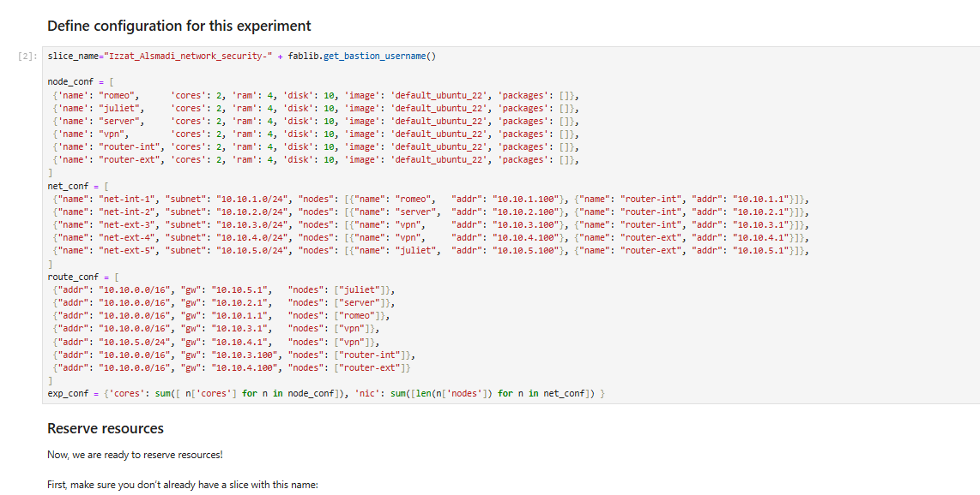
We also have to check if we resources are available and the slice already exists.
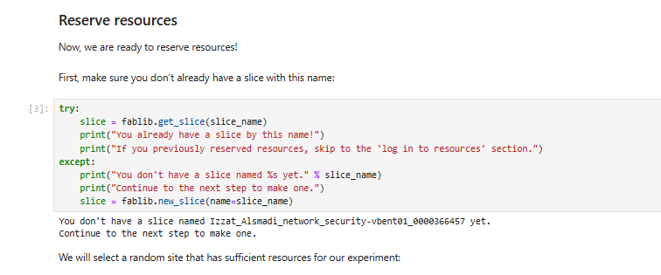
Just like every time we use the site =”EDUKY”
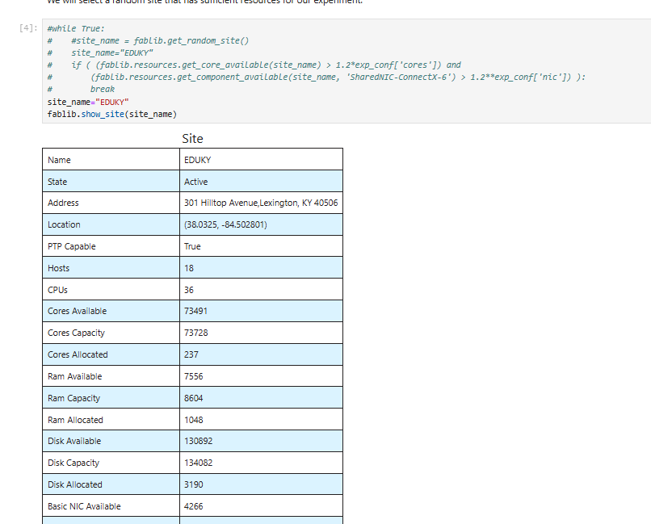
Then we set up the nodes and network segments
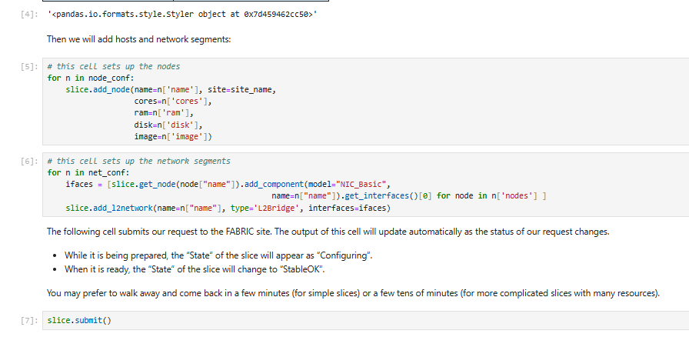
After running the command “slice.submit()”. We create a slice and wait for sometime for the status to change from ticketed to active

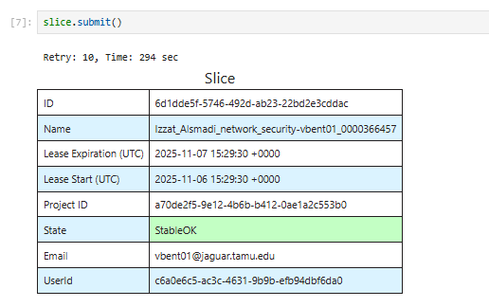
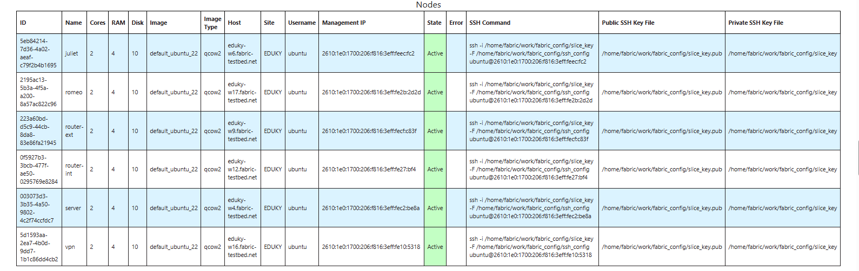
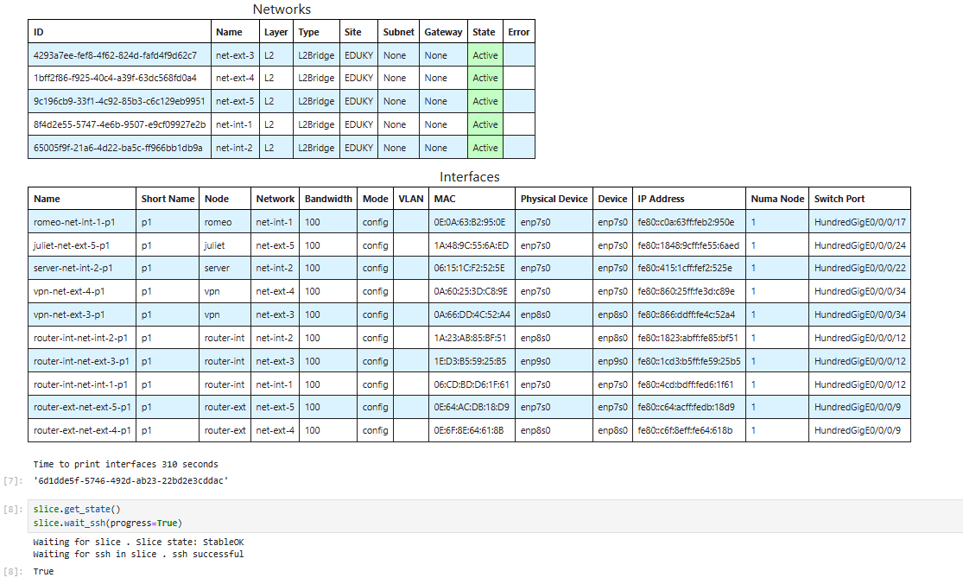
When we finally see the status is active, now we configure resources, and install few packages which are needed for this Experiment
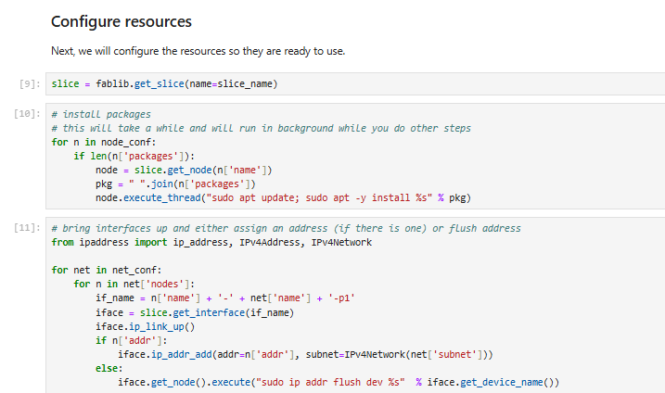
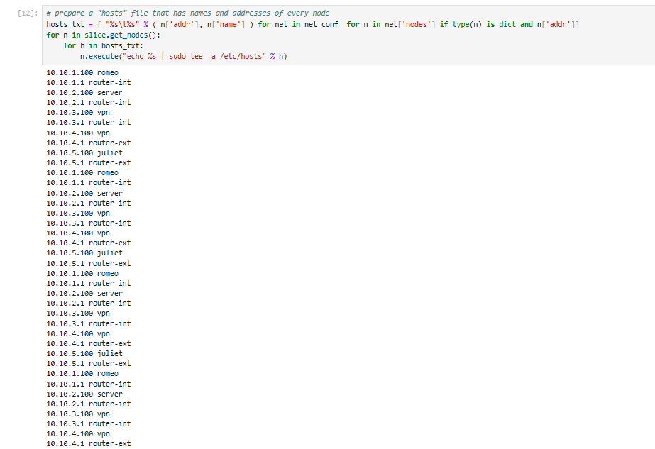
Now we enable IPv4 forwarding on all nodes
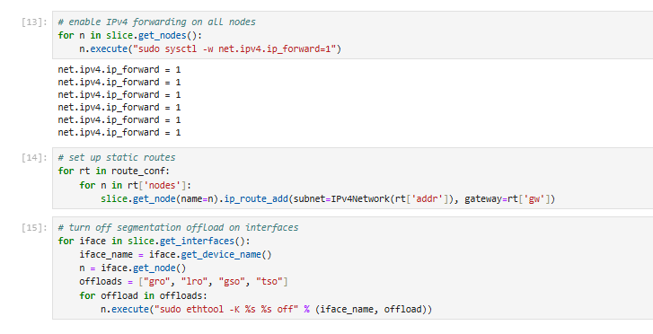
Now we draw the network topology
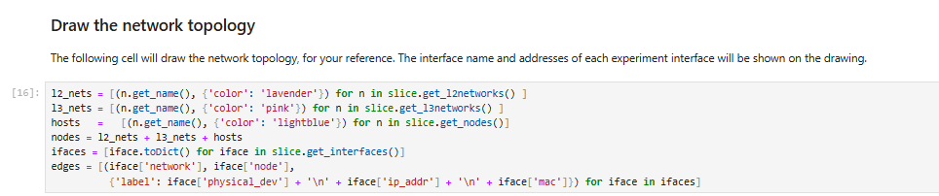
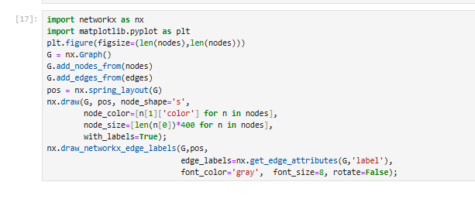
This is the network topology.

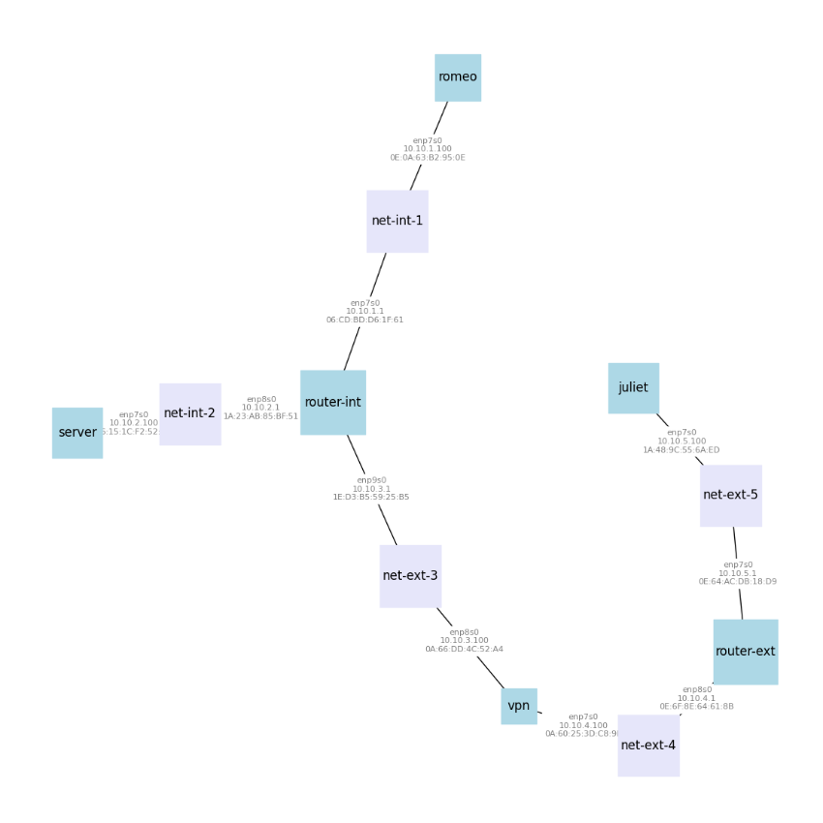
Then using this commands below we can directly see logs of resources (SSH commands).
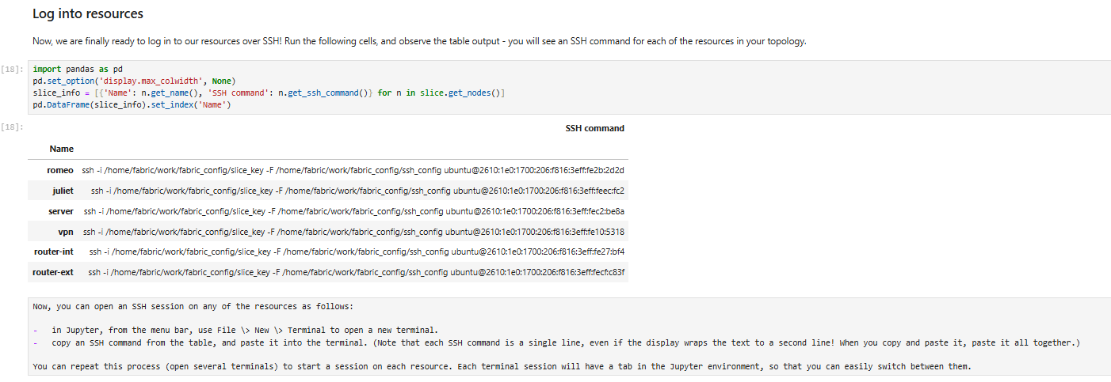
FTP and STFP setup
In this exercise, we will compare FTP and SFTP, two applications used for file transfer to and from a remote host. SFTP tunnels FTP traffic over an SSH session.
First, we need to install the FTP server on the "server" node:
First, we run the ssh command of the server.
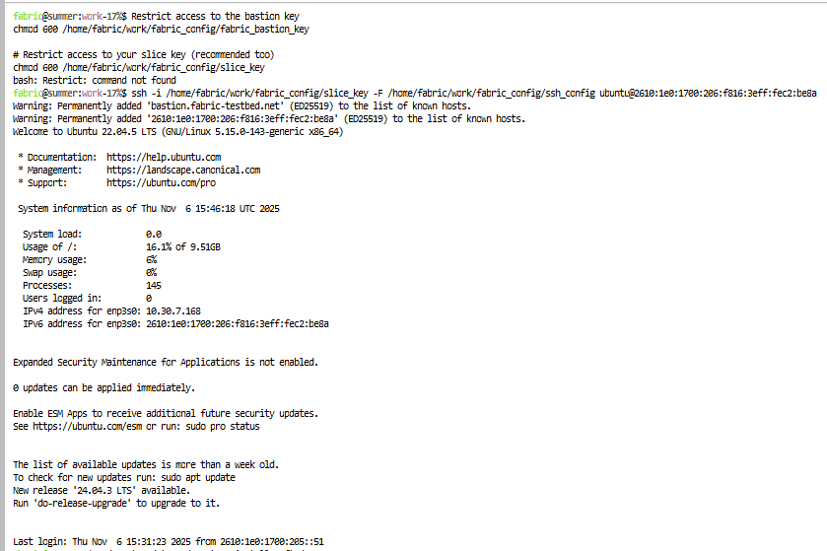
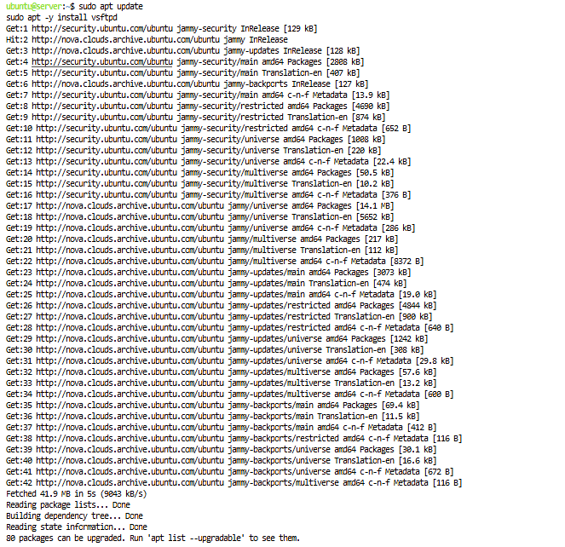
Then, we need to set up a user account for remote access to the "server" host. On the "server", create a new user account with the username "shakespeare" and then run: sudo passwd shakespeare

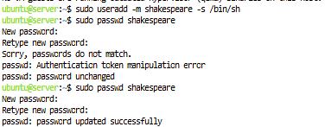
We will also need to start an SSH server for SFTP. On the "server", run
I left it running.

VPN setup:
First, we need to install the VPN service on the "vpn" node and on the "juliet" node, but before doing that we need to run the ssh command of Juliet in a new terminal.

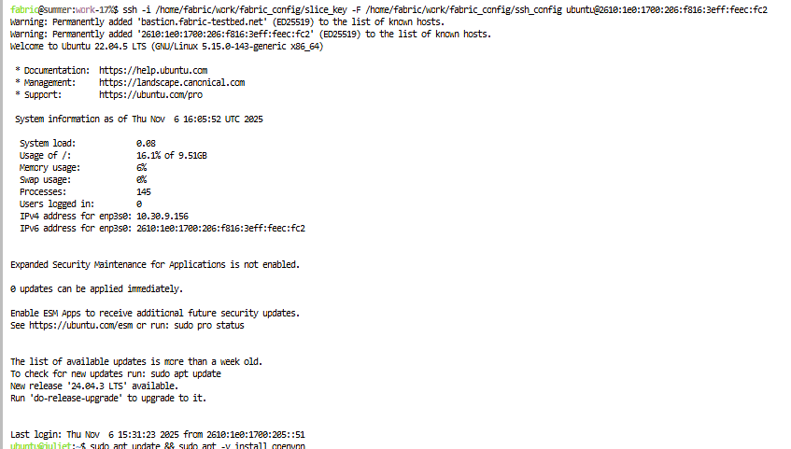

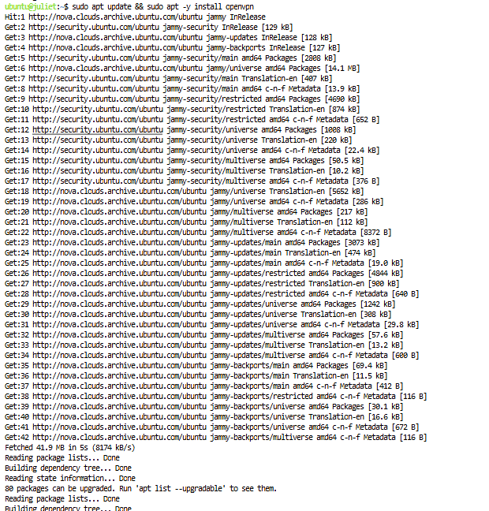

We run the ssh command of vpn in a new terminal
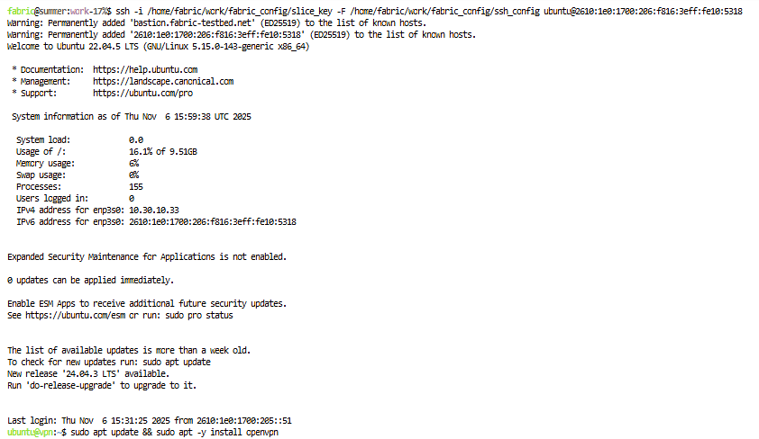

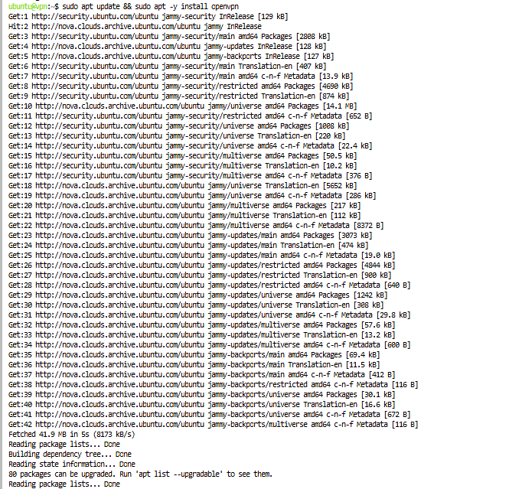

On "vpn", run: openvpn --genkey --secret static.key , to generate a cryptographic key. Then, run cat static.key

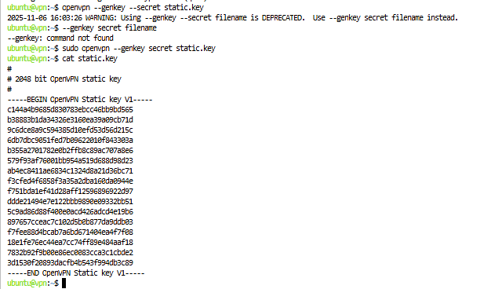
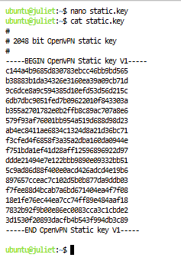

Next, we are going to set up routes for the VPN traffic.
For the VPN tunnel, we will use the 10.10.8.0/24 subnet. We need to set up routes for this network prefix throughout the "internet" network.
On the "server" node, run
On the "router-int" node, run
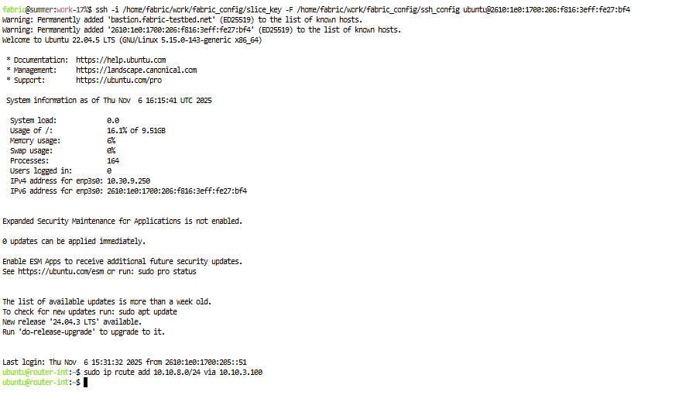
so that the traffic destined for the VPN tunnel will go to the "vpn" node.
Now we are ready to prepare the VPN configuration.
On "vpn", run nano server.ovpn, To create the OpenVPN configuration file, and place the following contents inside and

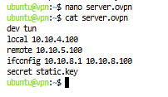
Then, run sudo openvpn server.ovpn to start the OpenVPN server. Leave this running.
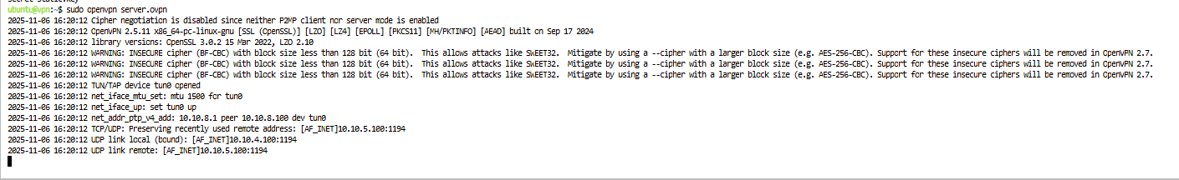
On the "juliet" node, run nano client.ovpn and place the following contents inside: dev tun
local 10.10.5.100
remote 10.10.4.100
ifconfig 10.10.8.100 10.10.8.1
secret static.key
route 10.10.2.0 255.255.255.0
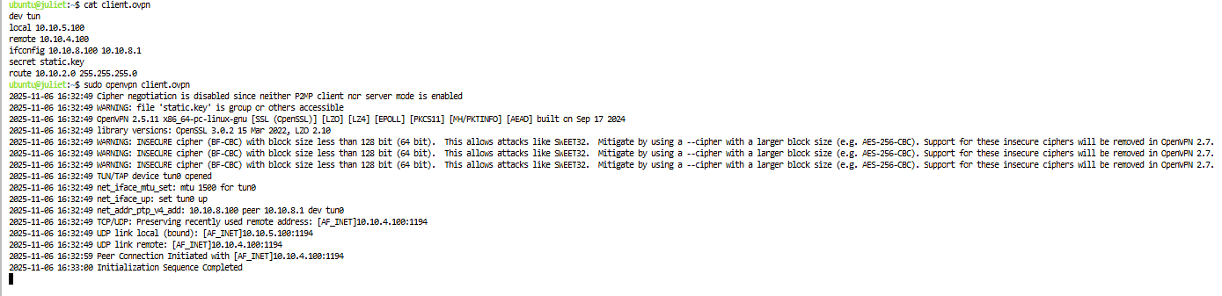
Then, run sudo openvpn client.ovpn to connect to the VPN. You can see
Initialization Sequence Completed in the output.
In a different terminal on "juliet", run ip addr and note the new tun0 interface. Also run ip route and save the output.

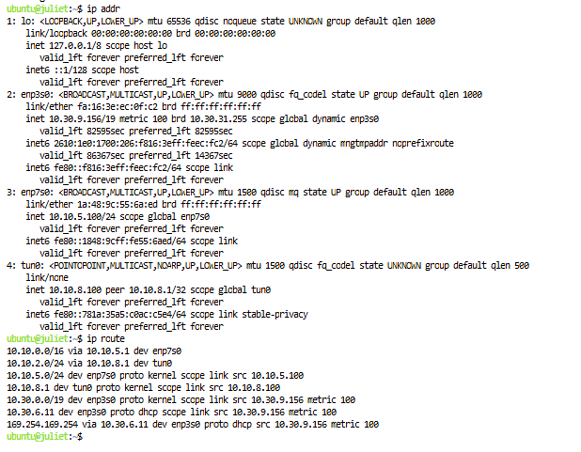
FTP and SFTP transfer over VPN
On the "router-ext" node and the "router-int" node, run: sudo tcpdump -i IFACE -w vpn-ftp-$(hostname -s).pcap

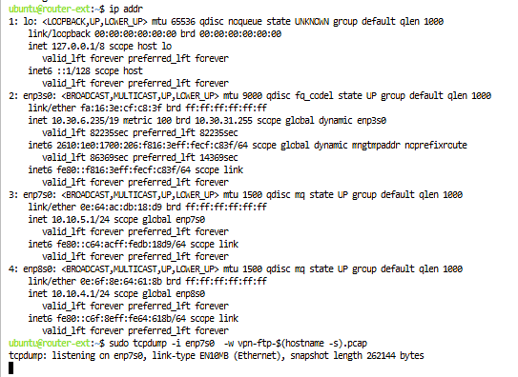
where in place of IFACE you use the interface name you identified as described above.
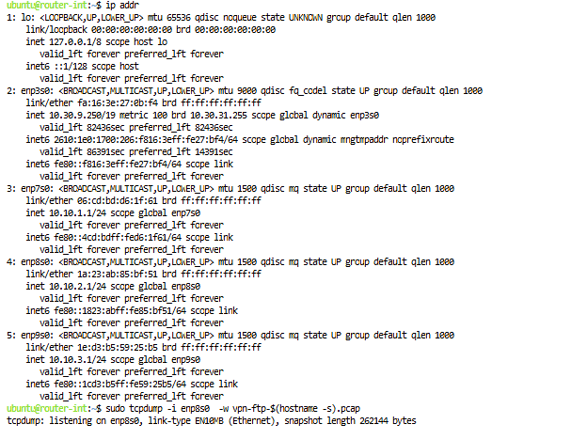
Then, on "juliet", run ftp server
When prompted for a "Name", enter Shakespeare and hit "Enter". Then, when prompted for a password, enter the password you set previously for the "shakespeare" user.

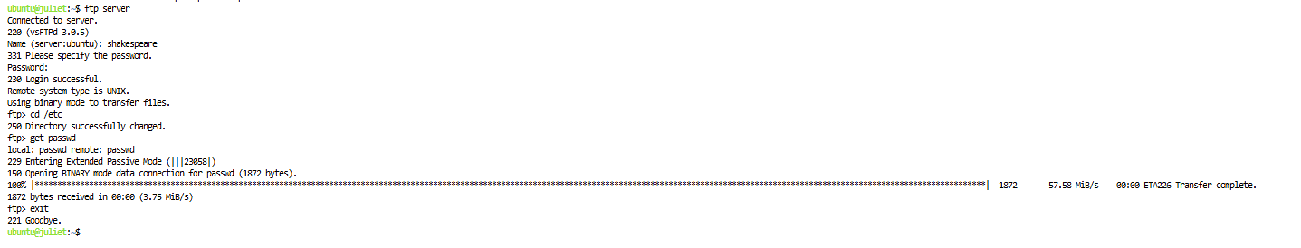
After we successfully authenticated FTP session ( we saw the message "230 Login successful"). At the FTP prompt, type cd /etc and get passwd. This will transfer a list of all usernames on the remote system over the FTP session. Finally, type exit in the FTP session and hit "Enter" to end it.

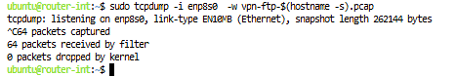
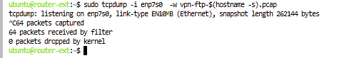
I stopped the tcpdump running on both routers with Ctrl+C, and used scp to transfer these to my laptop.
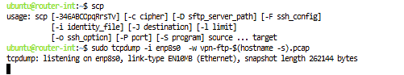
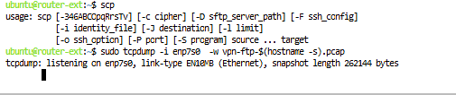
Next, we'll repeat with sftp, which offers application layer confidentiality. On the "router-ext" node and the "router-int" node, run sudo tcpdump -i IFACE -w vpn-sftp-$(hostname -s).pcap. where in place of IFACE you use the interface name you identified earlier. While this is running, initiate an SFTP connection from "juliet" to "server" on port 1000 - on "juliet", run sftp -P 1000 shakespeare@server

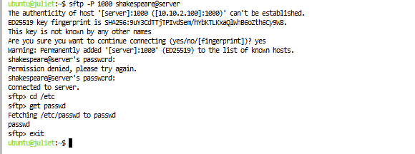
When prompted for a password, enter the password you set previously for the "shakespeare" user. At the SFTP prompt, type cd /etc and then get passwd to retrieve the same file. Then, type exit in the SFTP session and hit "Enter" to end it.

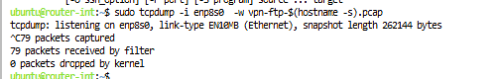
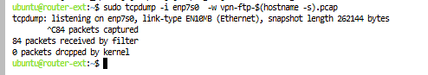
I stopped the tcpdump running on both routers with Ctrl+C, and use scp to transfer these to your laptop and then delete the slice.

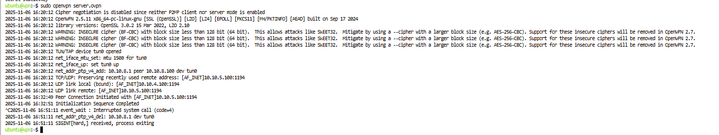
Below is the photo of deletion command executed successfully
